DIS-Bannerstone-TN

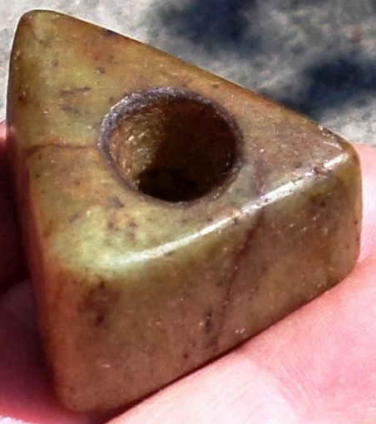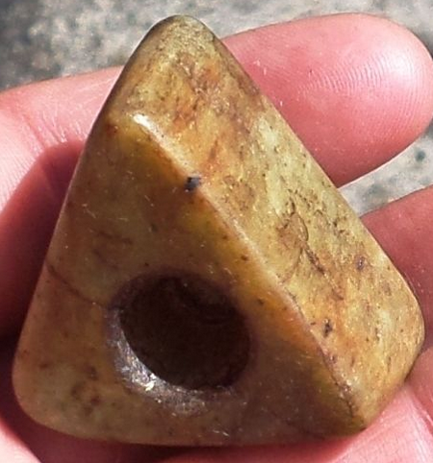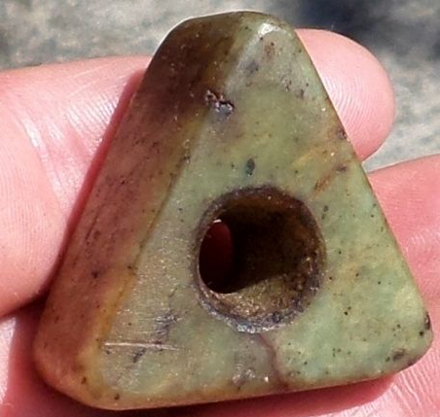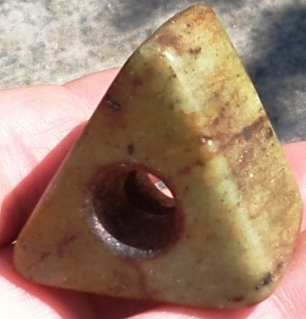

Large triangular bead that measures 1 5/8 in. x 1 in. This is either a bead or some kind of counter weight. It is in great condition. This piece is part of a collection from White Pine, Tennessee.